Classroom Management Strategy: Social-Emotional Learning

Article: How SEL Helps You As a Teacher by Shivohn N. García, PhD
and Classroom Management Strategies to Prompt Social-Emotional Learning from the Art of Education
Video: What is Social-Emotional Learning?

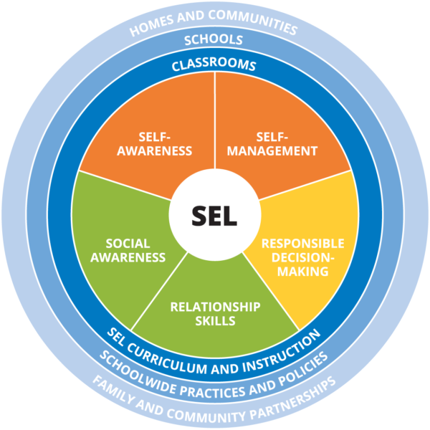 Image from CASEL.org​​

