Classroom Management Strategy: Restorative Justice
Article: “How Restorative Justice Helps Students Learn,” by Jacquelyn Richards at Edutopia
Video: What Is Restorative Justice?
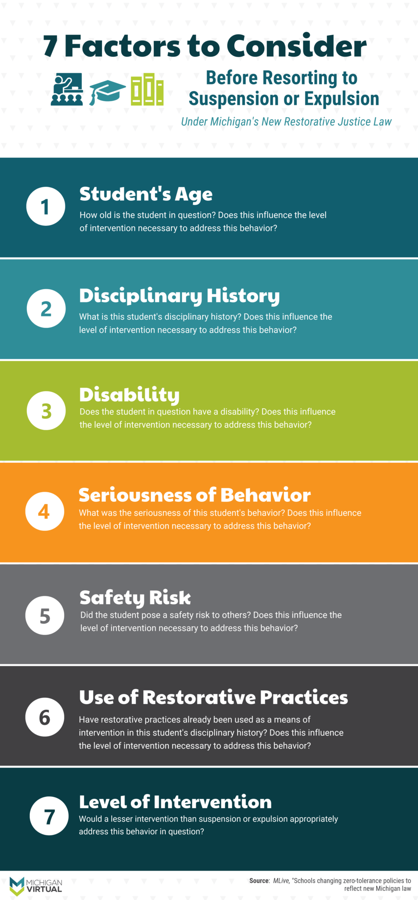
Image from Michigan Virtual

