Classroom Management Strategy: Conscious Discipline

Article: How to Use Conscious Discipline from Conscious Discipline
Video: Early Learning is Transformed with Conscious Discipline - The Story of Grow With Us Academy

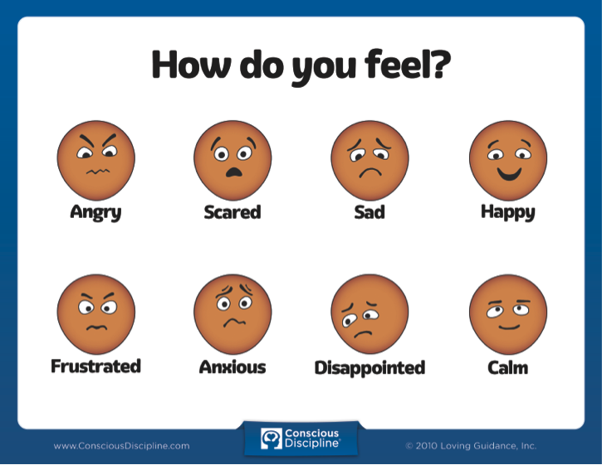

Image from Conscious Discipline

